A.I. and Robotics based IntelliShop
Capstone Project Report MID SEMESTER EVALUATION
Submitted by:

(102003162) | Deekshak
(102003337) | Sahil Dhillon
(102003356) | Naman Bhayana
(102003364) | Abhishek Gandhi

BE Third Year, CoE

CPG No: 119

Under the Mentorship of
Dr. Rajkumar Tekchandani
Assistant Professor



Computer Science and Engineering Department Thapar Institute of Engineering and Technology, Patiala

July 2023

ABSTRACT

This project proposes the development of a robot that can be used to help customers in retail shops. The robot will be controlled by an Arduino microcontroller and will be integrated with artificial intelligence (AI) to enable it to navigate the shop, detect objects, and pick them up. The robot will be able to communicate with customers through a mobile app, which will allow them to request the robot to pick up specific objects. The robot will then navigate to the location of the object, pick it up, and deliver it to the customer. The proposed robot has the potential to revolutionize the way retail shops operate. It can help to improve customer service, reduce the workload of employees, and free up space in the shop. The robot can also be used to collect data about customer behavior, which can be used to improve the layout of the shop and the selection of products. The project is divided into three phases mainly first is the Design and development of the robot: The robot will be designed and built using an Arduino microcontroller and a variety of sensors. The AI software will be developed to enable the robot to navigate, detect objects, and pick them up. Second is Testing and evaluation of the robot: The robot will be tested in a simulated environment to ensure that it can perform all of its intended functions. The AI software will also be evaluated to ensure that it is accurate and efficient. Third is Deployment of the robot in a retail shop: The robot will be deployed in a retail shop to test its performance in a real-world environment. The feedback from customers and employees will be collected to improve the robot's design and functionality.

DECLARATION

We hereby declare that the design principles and working prototype model of the project entitled
“A.I. and Robotics based IntelliShop” is an authentic record of our own work carried out in the Computer Science and Engineering Department, TIET, Patiala, under the guidance of Dr. Rajkumar Tekchandani during 6th semester (2023).

Date: 23rd August, 2023

Roll No. | Name | Signature
102003162 | Deekshak | 
102003337 | Sahil Dhillon | 
102003356 | Naman Bhayana | 
102003364 | Abhishek Gandhi | 


Counter Signed By:

Faculty Mentor:

Dr. Rajkumar Tekchandani
Assistant Professor, CSED
TIET, Patiala

ACKNOWLEDGEMENT

We would like to express our thanks to our mentor(s) Dr. Rajkumar Tekchandani. He has been of great help in our venture, and an indispensable resource of technical knowledge. He is truly an amazing mentor to have.
We are also thankful to Dr Shalini Batra, Head, Computer Science and Engineering Department, entire faculty and staff of Computer Science and Engineering Department, and also our friends who devoted their valuable time and helped us in all possible ways towards successful completion of this project. We thank all those who have contributed either directly or indirectly towards this project.
Lastly, we would also like to thank our families for their unyielding love and encouragement. They always wanted the best for us and we admire their determination and sacrifice.

Date: 23rd August, 2023

Roll No. | Name | Signature
102003162 | Deekshak | 
102003337 | Sahil Dhillon | 
102003356 | Naman Bhayana | 
102003364 | Abhishek Gandhi | 

TABLE OF CONTENTS

ABSTRACT…………………………………………………………………………………. i
DECLARATION……………………………………………………………………………ii
ACKNOWLEDGEMENT……………………………………………………………….... iii
LIST OF FIGURES………………………………………………………………………... iv
LIST OF TABLES…………………………………………………………………………..v
LIST OF ABBREVIATIONS……………………………………………………………... vi

CHAPTER………………………………………………………………………………Page No.

1- INTRODUCTION

1.1 Project Overview …………………………………………………............................1

1.1.1 Technical terminology…………………………………………………………

1.1.2 Problem statement…………………………………………………............................1

1.1.3 Goal…………………………………………………............................1

1.1.4 Solution…………………………………………………............................1

1.2 Need Analysis…………………………………………………............................3

1.3 Research Gaps…………………………………………………............................4

1.4 Problem Definition and Scope………………………………………………………4

1.5 Assumptions and Constraints…………………………………………………..........6

1.6 Standards…………………………………………………............................6

1.7 Objectives…………………………………………………............................7

1.8 Methodology Used…………………………………………………..................7

1.9 Project Outcomes and Deliverables……………………………………………9

1.10 Novelty of Work………………………………………………….......................9

2 - REQUIREMENT ANALYSIS

2.1 Literature Survey………………………………………………….........................10

2.1.1 Related Work…………………………………………………..........

2.1.2 Research Gaps of Existing Literature………………………………………

2.1.3 Detailed Problem Analysis………………………………………………….........

2.1.4 Survey of Tools and Technologies Used…………………………………………

2.1.5 Summary…………………………………………………..........

2.2 Software Requirements Specification………………………………………………….......15

2.2.1 Introduction…………………………………………………..........15

2.2.1.1 Purpose…………………………………………………..........15
2.2.1.2 Intended Audience and Reading Suggestions…………………..15

2.2.1.3 Project Scope…………………………………………………..........15

2.2.2 Overall Description…………………………………………………..........17

2.2.2.1 Product Perspective…………………………………………………........17

2.2.2.2 Product Features…………………………………………………..........

2.2.3 External Interface Requirements………………………………………………….....

2.2.3.1 User Interfaces…………………………………………………..........

2.2.3.2 Hardware Interfaces…………………………………………………..........

2.2.3.3 Software Interfaces…………………………………………………..........6

2.2.4 Other Non-functional Requirements…………………………………………………..

2.2.4.1 Performance Requirements…………………………………………

2.2.4.2 Safety Requirements…………………………………………………....

2.2.4.3 Security Requirements…………………………………………………..........

2.3 Cost Analysis…………………………………………………..........

2.4 Risk Analysis…………………………………………………..........

3 -METHODOLOGY ADOPTED…………………………………………………..........

3.1 Investigative Techniques…………………………………………………..........

3.2 Proposed Solution…………………………………………………..........

3.3 Work Breakdown Structure…………………………………………………..........

3.4 Tools and Technologies Used…………………………………………………..........

4 -DESIGN SPECIFICATIONS…………………………………………………..........

4.1 System Architecture ………………………….…………………

4.2 Design Level Diagrams…………………………………………………..........

4.3 User Interface Diagrams…………………………………………………..........

5 -IMPLEMENTATION AND EXPERIMENTAL RESULTS………………………………

5.1 Experimental Setup………………………………………………….........

5.2 Experimental Analysis…………………………………………………..........

5.2.1 Data…………………………………………………........

5.2.2 Performance Parameters…………………………………

5.3 Working of the project…………………………………………………..........

5.3.1 Procedural Workflow…………………………………………………..........

5.3.2 Algorithmic Approaches Used…………………………………………

5.3.3 Project Deployment…………………………………………………..........

5.3.4 System Screenshots…………………………………………………..........

5.4 Testing Process…………………………………………………..........

5.4.1 Test Plan…………………………………………………..........

5.4.2 Features to be tested…………………………………………………..........

5.4.3 Test Strategy…………………………………………………..........

5.4.4 Test Techniques…………………………………………………..........

5.4.5 Test Cases…………………………………………………..........

5.4.6 Test Results…………………………………………………..........

5.5 Results and Discussions…………………………………………………..........

5.6 Inferences Drawn…………………………………………………..........

5.7 Validation of Objectives…………………………………………………..........

6 -CONCLUSIONS AND FUTURE DIRECTIONS…………………………………………

6.1 Conclusions…………………………………………………..........

6.2 Environmental, Economic and Societal Benefits……………………………………………

6.3 Reflections…………………………………………………..........

6.4 Future Work………………………………………………….........

7 -PROJECT METRICS…………………………………………………..........

7.1 Challenges Faced…………………………………………………..........

7.2 Relevant Subjects…………………………………………………..........

7.3 Interdisciplinary Knowledge Sharing…………………………………………………..........

7.4 Peer Assessment Matrix…………………………………………………..........

7.5 Role Playing and Work Schedule………………………………………………….........

7.6 Student Outcomes Description and Performance Indicators (A-K Mapping) ………………

7.7 Brief Analytical Assessment………………………………………………….........

APPENDIX A: REFERENCES…………………………………………………..........

APPENDIX B: PLAGIARISM REPORT…………………………………………………..........

LIST OF TABLES

Table No. | Caption | Page No.
Table 1 | Assumption | 5
Table 2 | Constraints | 5
Table 3 | Research findings for existing literature | 12
Table 4 | Cost Analysis | 19
Table 5 | Use case template | 29

LIST OF FIGURES

Figure No. | Caption | Page No.
Figure 1 | System Architecture | 23
Figure 2 | Sequence Diagram | 24
Figure 3 | Class Diagram | 25
Figure 4 | Use Case Diagram | 26
Figure 5 | Activity Diagram | 28
Figure 6 | Working Prototype | 29

LIST OF ABBREVIATIONS

Abbreviations | Full Form
AI | Artificial Intelligence
HRI | Human Robot Interaction
ML | Machine Learning
UI | User Interface
UX | User Experience
NLP | Natural Language Processing
IEEE | Institute of Electrical and Electronics Engineers
WLAN | Wireless Local Area Network
IoT | Internet of Things
Wifi | Wireless Fidelity

INTRODUCTION

Project Overview
The AI-Enabled Robotic Retail Assistant project aims to revolutionize the retail experience by combining Arduino-based robotics and artificial intelligence (AI) to create an efficient and interactive customer service solution. This project involves the development of a robotic system that can assist customers in a retail shop by receiving object requests through a custom mobile application. The robot will autonomously navigate the store, locate the requested items, and deliver them to the customer, enhancing customer convenience and engagement.

Project Objectives:

Automation of Customer Assistance: The primary objective is to design and construct a robot capable of navigating the store environment, identifying customer requests, and retrieving the specified items.

Intelligent Object Recognition: Implement AI algorithms to enable the robot to recognize and distinguish different products accurately, ensuring it selects the correct item based on customer requests.

Seamless User Interaction: Develop a user-friendly mobile application that allows customers to input their product requests. The app will facilitate efficient communication between customers and the robotic assistant.

Safe and Reliable Operation: Prioritize safety by integrating obstacle detection and collision avoidance mechanisms into the robot's design, ensuring smooth navigation and preventing accidents.

Components and Technologies:

Arduino Platform: The robot's hardware will be built on the Arduino platform, which offers flexibility, ease of integration, and compatibility with various sensors and actuators.

Robot Chassis and Actuators: Design and assemble a robot chassis equipped with wheels or tracks for mobility. Incorporate servo motors or robotic arms for picking and delivering objects.

Sensors: Integrate a variety of sensors, including ultrasonic sensors, cameras, to provide the robot with environmental awareness, object detection, and navigation capabilities.

AI and Machine Learning: Implement machine learning techniques for object recognition and classification. Train a neural network to identify different products based on visual input from the robot's cameras.

Mobile Application: Develop a mobile app that enables customers to submit their item requests, track the robot's progress, and receive notifications when their items are ready for pickup.

Project Phases:

Design and Prototyping: Create a detailed design of the robot's chassis, including its physical structure and layout of components. Build a prototype to validate the design.

Sensor Integration: Incorporate sensors for navigation, obstacle avoidance, and object detection. Calibrate and test sensor accuracy.

AI Model Development: Train a machine learning model to recognize and classify products. Optimize the model for accuracy and speed.

Mobile App Creation: Design and develop a user-friendly mobile application for customers to interact with the robot.

Integration and Testing: Integrate all components, including hardware, software, and AI modules. Conduct thorough testing to ensure proper functionality and communication between the robot and the app.

Optimization and Refinement: Fine-tune the robot's performance, AI accuracy, and user interface based on testing results and user feedback.

Documentation and Reporting: Create comprehensive documentation, including system architecture, circuit diagrams, software code, and user guides. Prepare a final report summarizing the project's objectives, process, challenges, and outcomes.

Expected Outcomes:

The AI-Enhanced Retail Assistance Robot project aims to bridge the gap between robotics and AI to provide a novel customer service solution for retail environments. By combining innovative hardware design, sophisticated AI recognition capabilities, and a user-friendly mobile application, the project aspires to create a new standard in retail customer experience. The successful execution of this project could potentially revolutionize the retail industry and inspire further research and development at the intersection of AI and robotics.
By seamlessly blending hardware, software, and artificial intelligence, the project exemplifies innovation and creativity in engineering, automation, and customer service.

Need Analysis

1. Customer Convenience and Experience Enhancement: Customers often require assistance in locating and retrieving specific items in large retail stores, leading to inconvenience and potential frustration.

2. Efficiency and Time Saving: Traditional customer assistance methods can be time-consuming and may require multiple interactions with store staff to locate items.

3. Personalization and Engagement: Retail customers appreciate personalized experiences that make them feel valued and engaged.

4. Labor Optimization and Cost Efficiency: Retail stores often require a significant workforce to assist customers, leading to increased labor costs.

5. Inventory Management and Accuracy: Accurate inventory management is crucial for retailers to ensure that products are in stock and readily available for customers.

6. Technological Innovation and Showcase: Businesses are constantly seeking innovative ways to differentiate themselves and capture customer attention.

7. Safety and Customer Well-being: Crowded retail environments can sometimes lead to accidents or discomfort for customers.

8. Data Collection and Insights: Retailers often seek insights into customer behavior and preferences to improve their services and product offerings.

9. Future-Proofing and Adaptability: Businesses need solutions that can adapt to changing technologies and consumer expectations.

10. Differentiation and Competitive Advantage: In a competitive retail landscape, businesses strive to stand out and attract customers.

1.3 Research Gaps

From the literature survey conducted, the following research gaps were identified:
- Human-Robot Interaction (HRI) in Retail Environments: Despite advancements in robotics and AI, there is a lack of comprehensive research on optimizing human-robot interaction specifically in retail settings. The project would benefit from further exploration of how customers perceive and interact with the robot, including aspects of trust, communication, and ease of use.
- Real-Time Navigation and Obstacle Avoidance: While path planning and obstacle avoidance algorithms exist, adapting them to real-time retail environments with dynamic obstacles (e.g., other customers, carts) requires research. Ensuring safe and efficient navigation without causing disruptions or delays in a crowded store setting is a research gap.
- Adaptive Learning and Continual Improvement: Research gaps exist in the area of adaptive learning for the AI model. How the system can learn from its interactions, adapt to new items or changes in the store layout, and improve its accuracy over time are areas requiring more investigation.

1.4 Problem Definition & Scope

Project Definition:

The AI-Enabled Robotic Retail Assistant project aims to develop a robotic system integrated with artificial intelligence (AI) capabilities to enhance the customer experience in a retail shop. The project involves the design, construction, and implementation of a robot that can autonomously navigate the store environment, recognize customer requests through a mobile application, locate requested items, and deliver them to customers. By seamlessly blending hardware, software, and AI, the project seeks to revolutionize traditional retail practices, demonstrating the potential of technology to create efficient and engaging customer service solutions.

Project Scope:

1. Hardware Development:

Design and construct a robot chassis with mobility mechanisms (wheels or tracks).
Integrate necessary sensors for navigation, obstacle detection, and object recognition (e.g., ultrasonic sensors, camera).

2. Software Development:

Develop algorithms for autonomous navigation, obstacle avoidance, and path planning within the store. Implement AI algorithms for object recognition and classification to identify different products.
Create a user-friendly mobile application for customers to submit item requests and interact with the robot.

3. AI Model Training:

Train a machine learning model to accurately recognize and classify various products based on visual input from the robot's cameras. Optimize the AI model for accuracy and speed, considering the real-time nature of the robotic assistant's tasks.

4. Mobile App Integration:

Establish seamless communication between the mobile application and the robot, ensuring efficient transmission of customer requests and notifications.

5. Navigation and Interaction:

Enable the robot to navigate the store autonomously, avoiding obstacles and following optimal paths to requested items. Design the robot's interaction behaviors, such as approaching customers, receiving items, and delivering them.

6. User Experience:

Prioritize a positive user experience by ensuring intuitive app design, clear instructions for customers, and friendly robot behaviors.

7. Safety and Reliability:

Implement safety mechanisms to prevent collisions, ensuring the robot's movement does not pose a risk to customers or itself. Test and validate the reliability of the robot's hardware and software components.

8. Data Collection and Insights:

Collect and analyze data related to customer preferences, frequently requested items, and interaction patterns for future improvements.

9. Documentation and Reporting:

Create comprehensive documentation for the project, including system architecture, circuit diagrams, software code, and user guides. Prepare a final report summarizing the project's objectives, methodology, challenges, outcomes, and recommendations.

1.5 ASSUMPTIONS AND CONSTRAINTS

SNO. | ASSUMPTIONS
1 | Shelfs of store are considered to be in a parallel line.
2 | Assuming that weight of objects is low.
3 | Assuming the object width should be less than 4 cm.

Table 1: Assumptions

SNO. | CONSTRAINTS
1 | Technological Infrastructure: The project's success depends on the availability of technology infrastructure, as there will be too many api requests.
2 | Data Accuracy: The accuracy of recommendations is constrained by the accuracy of input data. Inaccurate or incomplete data could lead to less effective recommendations.

Table 2: Constraints

1.6 Standards

AI-Enabled Robotic Retail Assistant, adhering to several IEEE (Institute of Electrical and Electronics Engineers) standards that pertain to robotics, AI, and software development. While the specific standards to follow depend on the project's context and goals, here are some relevant IEEE standards that is applicable to our project:

IEEE 12207: Standard for Systems and Software Engineering - Software Life Cycle Processes:
This standard provides guidelines for software development processes, including requirements, design, implementation, testing, and maintenance. Adhering to this standard can help ensure a well-structured and organized software development approach.

IEEE 15288: Systems and Software Engineering - System Life Cycle Processes:
Similar to IEEE 12207 but focused on systems engineering, this standard outlines processes for developing complex systems. Given the integration of hardware and software in your project, this standard can offer valuable insights.

IEEE 1872: Guide for Architecture Description of Software-Intensive Systems:
As our project involves both software and hardware components, this guide helps us describe the architecture of your system effectively, ensuring clear communication of the design to stakeholders.

IEEE 802.11: Wireless LAN (WLAN) Standards:
Project requires wireless communication between the robot and the mobile app, IEEE 802.11 standards guides the design and implementation of the communication protocols.
IEEE 1451: Smart Transducer Interface Standards:
IEEE 1451 standards provide a framework for interoperable interfaces between sensors and systems.

IEEE 1874: Standard for Model and Metamodel for Systems Engineering:
This standard focuses on modeling systems and their interactions, which is useful for creating comprehensive models of our project architecture and behavior.

1.7 Approved Objectives

- Automation of Customer Assistance: The primary objective is to design and construct a robot capable of navigating the store environment, identifying customer requests, and retrieving the specified items.

- Intelligent Object Recognition: Implement AI algorithms to enable the robot to recognize and distinguish different products accurately, ensuring it selects the correct item based on customer requests.

- Seamless User Interaction: Develop a user-friendly mobile application that allows customers to input their product requests. The app will facilitate efficient communication between customers and the robotic assistant.

- Safe and Reliable Operation: Prioritize safety by integrating obstacle detection and collision avoidance mechanisms into the robot's design, ensuring smooth navigation and preventing accidents.

1.8 Methodology

The development of the AI-Enabled Robotic Retail Assistant involves a systematic methodology that encompasses various stages from design to implementation. The methodology outlined below ensures a structured approach to achieving the project's objectives.

1. Project Planning and Requirements Gathering:

Define the project's scope, objectives, and expected outcomes. Gather requirements from stakeholders, including the retail store's management and potential customers. Determine the hardware specifications, sensors, and AI model requirements.

2. Hardware Design and Assembly:

Design the robot's chassis, considering mobility mechanisms, weight distribution, and space constraints within the store. Select and integrate the required sensors for navigation, obstacle avoidance, and object recognition.
Assemble the hardware components, including motors, sensors, and power supply.

3. Software Development:

Develop software algorithms for real-time navigation using path planning, obstacle avoidance, and localization techniques. Create a software interface for integrating sensor data and enabling communication between hardware components. Design and implement the AI model training pipeline for object recognition and classification.

4. Mobile Application Development:

Develop a mobile application with an intuitive user interface for customers to submit item requests and interact with the robot. Implement communication protocols between the app and the robot's software system.

5. AI Model Training and Optimization:

Collect and preprocess a diverse dataset of product images for training the AI model.
Train the AI model using machine learning frameworks, optimizing for accuracy and speed.
Fine-tune the model to ensure it can accurately identify and classify various products.

6. Integration and Testing:

Integrate the hardware components, software algorithms, and the trained AI model to create a functional robotic system. Conduct extensive testing of individual components, subsystems, and the overall system to identify and resolve issues.

7. Navigation and Interaction Behavior Design:

Design the robot's navigation behavior, ensuring it can autonomously navigate the store environment and avoid obstacles. Develop interaction behaviors, including recognizing customers, receiving item requests, and delivering items.

8. User Experience and Interface Refinement:

Iterate on the mobile app's user interface design based on user feedback and usability testing.
Refine robot behaviors to ensure they align with user expectations and create a positive customer experience.

9. Safety and Reliability Assurance:

Implement safety mechanisms such as obstacle detection, collision avoidance, and emergency stop features. Test the robot's movements and behaviors in a controlled environment to ensure customer and robot safety.

10. Data Collection and Insights:

Implement data collection mechanisms to gather insights into customer interactions, preferences, and usage patterns. Analyze collected data to identify trends and make informed decisions for improvements.

11. Documentation and Reporting:

Document the entire project, including system architecture, hardware schematics, software code, and AI model details. Prepare a comprehensive report summarizing the methodology, challenges faced, solutions implemented, and project outcomes.
12. Deployment and Evaluation:

Deploy the robotic assistant in the retail store environment. Continuously monitor its performance, gather user feedback, and assess the impact on customer experience.

13. Continuous Improvement:

Based on user feedback and collected data, make iterative improvements to the robot's behavior, app interface, and overall system.

1.9 Project Outcomes and Deliverables

Project Outcomes:

Successful completion of the AI-Enabled Robotic Retail Assistant project will result in a tangible robotic system that showcases the integration of AI and robotics to enhance customer service in a retail setting. The project aims to improve customer convenience, efficiency, and engagement, while also contributing to the fields of robotics, AI, and human-robot interaction.

Project Deliverables:

Fully functional robot capable of navigating, recognizing items, and interacting with customers.
Mobile application enabling customers to submit requests and interact with the robot.
Trained AI model for accurate object recognition.
Comprehensive documentation including design specifications, software code, and user guides.

Novelty of Work

- Use of Arduino Programming
- Use of computer vision and object detection YOLO v3 model using tinyML.
- An easy-to-use interface and front-end application for human-robot interaction.

REQUIREMENT ANALYSIS

Literature Survey

The following chapter covers the details about the literature survey performed, focusing on the existing technology, the technology on which the team worked and all the necessary theory associated with the problem area. The following chapters address only the techniques that are either necessary towards understanding the evolution of the field or have gained popularity with the researchers due to their better performance.

Theory Associated with Problem Area

In this ambitious project, the theoretical foundation encompasses a wide range of disciplines. At its core, robotics theory guides the understanding of the robot's physical capabilities, including its kinematics and the operation of its actuators. Essential to this endeavor is the integration of various sensors such as ultrasonic sensors and cameras, underpinning the robot's ability to perceive its environment and identify objects. The realm of artificial intelligence (AI) theory plays a pivotal role, with machine learning algorithms facilitating tasks like object recognition and path planning, and computer vision techniques enabling object detection and tracking. Additionally, for human interaction, particularly with customers, principles of natural language processing (NLP) come into play. On the programming front, proficiency in Arduino programming is indispensable for controlling the robot's hardware and sensor interfaces. As the robot is tasked with object detection and navigation within a retail environment, understanding path planning algorithms like A* and Dijkstra's is crucial. Considerations extend beyond technical aspects to encompass the ethical implications of deploying AI-powered robots in public spaces and the implementation of safety mechanisms. An emphasis on user experience (UX) design ensures that the customer-facing app is intuitive and user-friendly, while data security principles safeguard sensitive customer information. Moreover, the project delves into IoT integration, scalability, regulatory compliance, cost management, and maintenance strategies, all working together to create a holistic solution. Continuous improvement mechanisms driven by AI and a feedback loop from customers and shop staff are integrated to refine the robot's performance over time. In essence, this project spans a diverse spectrum of theories and practices, blending robotics, AI, programming, UX design, and ethical considerations into a comprehensive retail assistance solution.

Existing Systems and Solutions
- Amazon Scout: Amazon Scout is a delivery robot that is being tested in a few cities in the United States. The robot is designed to deliver packages to customers' homes and businesses. It uses a variety of sensors to navigate and avoid obstacles.
- Fetch: Fetch is a robot that is designed to help with warehouse logistics. The robot can pick up and move boxes, and it can also navigate around obstacles.
- Optimus Autonomous Mobile Robot: The Optimus Autonomous Mobile Robot is a robot that is designed for a variety of applications, including retail, healthcare, and hospitality. The robot can navigate autonomously and interact with customers.
- Nauto: Nauto is a company that develops technology for self-driving cars. The company's technology can be used to develop robots that can navigate and interact with the environment.
- Stanley Innovation: Stanley Innovation is a company that develops robots for a variety of applications, including retail, healthcare, and hospitality. The company's robots are designed to be safe and efficient.

Research Findings for Existing Literature

TABLE 3: Literature Survey and research findings
S. No. | Roll No. | Name of Student | Authors | Paper Title | Technology and Tools | Findings | Citation
1 | 1020033364 | Abhishek Gandhi | Rajasshrie Pillai, Brijesh Sivathanu , Yogesh K. Dwivedi | Shopping intention at AI-powered automated retail stores (AIPARS) | AI and Machine Learning | AIPARS Adoption in India | Link
 |  |  | Venkatesh Shankar, Kirthi Kalyanam, Pankaj Setia, Alireza Golmohammadi, Seshadri Tirunillai, Tom Douglass, John Hennessey, J.S. Bull, Rand Waddoups | How Technology is Changing Retail | AI, Machine Learning | Tech Transforms Retail Landscape | Link
 |  |  | Hector Gonzalez-Jimenez | Taking the fiction out of science fiction: (Self-aware) robots and what they mean for society, retailers and marketers | Robots | Robots in retail | Link
2 | 102003162 | Deekshak | Bogue, R. | Strong prospects for robots in retail | Arduino, Machine Learning | Retail Embraces Rapid Robotics | Link
 |  |  | Lanlan Cao | Artificial intelligence in retail: applications and value creation logics | AI | AI data management strategies, solutions, value creation. | Link
 |  |  | Roberto Grandinetti | How artificial intelligence can change the core of marketing theory | AI | AI in market | Link
3 | 102003337 | Sahil Dhillon | Praveen Kumar Donepudi | Robots in Retail Marketing: A Timely Opportunity | Robot, AI | Tech Shapes Retail Evolution | Link
 |  |  | Joseph Redmon, Ali Farhadi | YOLOv3: An Incremental Improvement | YoloV3, AI | Yolov3 object detection | Link
4 | 102003356 | Naman Bhayana | Christina Soyoung Song, Youn-Kyung Kim | The role of the human-robot interaction in consumers’ acceptance of humanoid retail service robots | Robot | Human Robot Interaction | Link
 |  |  | Lu Lu, Ruiying Cai, Dogan Gursoy | Developing and validating a service robot integration willingness scale | Robot, AI | AI, Robots in hospitality | Link

Problem Identified

The identified problem revolves around enhancing customer assistance and retail efficiency. Challenges include slow customer service, inventory management issues, high labor costs, and the need for better data utilization. To remain competitive, retailers seek innovative solutions to engage customers, secure data, and streamline supply chains. Addressing these concerns requires the integration of robotics and AI, as highlighted in the project's objective of creating a customer-assisting robot.

Survey of Tools and Technologies Used

Deep Learning frameworks used: Arduino Uno, Node MCU, ESP 32 CAM, Sensors, YOLO V3
Arduino Uno:
The Arduino Uno is a versatile microcontroller board that serves as the brain of robotic system. It features a user-friendly interface, making it a popular choice for projects like ours. The Arduino Uno controls various hardware components, processes sensor data, and executes algorithms to enable the robot's movement, interaction, and decision-making.

Node MCU:
The Node MCU is an open-source development board based on the ESP8266 microcontroller. It offers built-in Wi-Fi capabilities, enabling seamless communication between the robot and other devices. The Node MCU likely facilitates wireless connectivity, allowing the robot to receive commands from the mobile application and send status updates back to it.

ESP 32 CAM:
The ESP32 CAM is another development board, but it's equipped with a camera module. This module enables visual data capture and processing. In your project, the ESP 32 CAM could be used for object recognition tasks, where the YOLO V3 algorithm analyzes camera feed to identify products in the retail environment.

Sensors:
Sensors play a crucial role in the robot's perception of its surroundings. Including ultrasonic sensors for distance measurement and obstacle detection, cameras for visual data capture, and potentially other environmental sensors for enhanced situational awareness. These sensors feed real-time data to the microcontrollers, allowing the robot to make informed decisions during navigation and interactions.

YOLO V3:
YOLO (You Only Look Once) V3 is a state-of-the-art deep learning algorithm for object detection and classification. YOLO V3 is likely deployed on the ESP 32 CAM to identify and classify products in the store environment. Its efficiency in real-time processing makes it suitable for quick and accurate object recognition, a crucial aspect of your robotic retail assistant's functionality.

By leveraging these tools and technologies, it harnesses the power of microcontrollers, wireless communication, visual perception, and advanced AI algorithms to create a seamlessly integrated system that enhances the retail experience for customers and store operators alike.

2.2 Software Requirement Specification

The Software Requirement Specification (SRS) for the project involves a comprehensive outline of the software components and functionalities required to create an efficient customer-assisting robot for a retail environment. It must specify the development platform, programming languages, and frameworks necessary for the robot's control system and the accompanying mobile app. The SRS should detail the user interface design, including screens, navigation, and accessibility features, ensuring a seamless experience for both customers and store staff. Additionally, it must outline the AI algorithms and machine learning models needed for tasks such as object recognition, path planning, and natural language processing for customer interactions. Data security and privacy requirements are critical, highlighting encryption protocols and compliance with relevant regulations. Finally, the SRS should include scalability considerations, ongoing maintenance needs, and a clear testing strategy to ensure the robust performance of the software in a dynamic retail setting.

Introduction
Here onwards the preceding sections provide a comprehensive description of intended purpose and environment for the system we are developing.

2.2.1.1 Purpose

The purpose of this project is to develop a customer-assisting robot integrated with AI to enhance retail efficiency and improve the shopping experience.

2.2.1.2 Intended Audience and Reading Suggestions
The system is intended for students who want to add color information to a grayscale image in a realistic way since image colorization is the process of adding chrominance values to an input grayscale image.

Project Scope

1. Hardware Development:

Design and construct a robot chassis with mobility mechanisms (wheels or tracks).
Integrate necessary sensors for navigation, obstacle detection, and object recognition (e.g., ultrasonic sensors, camera).

2. Software Development:

Develop algorithms for autonomous navigation, obstacle avoidance, and path planning within the store. Implement AI algorithms for object recognition and classification to identify different products.
Create a user-friendly mobile application for customers to submit item requests and interact with the robot.

3. AI Model Training:

Train a machine learning model to accurately recognize and classify various products based on visual input from the robot's cameras. Optimize the AI model for accuracy and speed, considering the real-time nature of the robotic assistant's tasks.

4. Mobile App Integration:

Establish seamless communication between the mobile application and the robot, ensuring efficient transmission of customer requests and notifications.

5. Navigation and Interaction:

Enable the robot to navigate the store autonomously, avoiding obstacles and following optimal paths to requested items. Design the robot's interaction behaviors, such as approaching customers, receiving items, and delivering them.

6. User Experience:

Prioritize a positive user experience by ensuring intuitive app design, clear instructions for customers, and friendly robot behaviors.

7. Safety and Reliability:

Implement safety mechanisms to prevent collisions, ensuring the robot's movement does not pose a risk to customers or itself. Test and validate the reliability of the robot's hardware and software components.

8. Data Collection and Insights:

Collect and analyze data related to customer preferences, frequently requested items, and interaction patterns for future improvements.

9. Documentation and Reporting:

Create comprehensive documentation for the project, including system architecture, circuit diagrams, software code, and user guides. Prepare a final report summarizing the project's objectives, methodology, challenges, outcomes, and recommendations.
.

2.2.2 Overall Description

Our project integrates cutting-edge technologies, including artificial intelligence (AI), robotics, and mobile applications, to revolutionize the retail sector. With a focus on enhancing customer experiences, our solution employs autonomous robots that navigate stores, identify items using advanced AI object recognition, and interact with customers through a user-friendly mobile app. The project's holistic approach involves hardware design, software development, and AI model training. By seamlessly integrating these components, we aim to create a new paradigm for retail service, providing efficient, personalized, and interactive assistance to customers. The project embodies the future of retail, where technology elevates customer engagement and operational efficiency.

Product Perspective

This endeavor presents an opportunity to revolutionize the retail landscape through the integration of cutting-edge robotics and AI technologies. By creating a customer-assisting robot, the project aligns with the growing demand for efficient and personalized shopping experiences. It offers the potential to streamline retail operations, reduce labor costs, and enhance customer engagement.

2.2.2.2 Product Features

1. Autonomous Assistance: The project's standout feature is the robot's ability to autonomously navigate the retail environment, efficiently locating and retrieving customer-requested items. This reduces wait times and enhances the shopping experience.

2. Intelligent Interaction: The inclusion of natural language processing (NLP) empowers the robot to engage in meaningful conversations with customers, addressing inquiries and providing assistance, making the shopping process more interactive and personalized.

3. Data-Driven Insights: Through data analytics, the project generates valuable insights for retailers, aiding in inventory management and decision-making processes. It not only streamlines operations but also allows for better customer engagement and informed business strategies.

External Interface Requirements

External interface requirements specify the hardware, software or database structures a system should be interfaced with to provide the required functioning. The following section will provide information about the system as to how it will communicate properly with external components. If different portions of the system have different external interfaces, this section will be providing a detailed requirement for each portion. Let us look at each of the requirements of our system.

User Interfaces

The user interface for this project is designed with utmost simplicity and convenience. A user-friendly mobile app enables customers to effortlessly request assistance and track orders in real-time. It provides intuitive navigation, ensuring a seamless experience, while also allowing store staff to interact with the robot, streamlining retail operations with ease and efficiency.

Hardware Interfaces

This system interfaces with IoT devices for environment sensing and data transmission, ensuring seamless integration between robot and the digital system.
IoT Controllers: The system interfaces with various IoT devices (e.g., nodeMCU, Arduino UNO, ESP32-cam, ultrasonic sensor, servos, motors) to sense objects in environment and act accordingly for movement and arm function of robot.
Data Transmission: The system requires reliable communication channels (e.g., Wi-Fi, cellular networks) for transmitting data from robot to the cloud-based server and vice-versa.

Software Interfaces

This System integrates with external software components to enable navigation, data analysis and user authentication.
Cloud-Based Server (e.g., Firebase): The system interfaces with a cloud-based server to securely store, manage, and retrieve data collected from IoT sensors.
Deep Learning model: The system integrates with deep learning model (Yolov3) for developing and implementing object detection.
User Authentication Services: Integration with user authentication services ensures secure access to the app interface.
The seamless interaction between user interfaces, hardware components, and software libraries ensures the System's effectiveness in providing accurate object detection in retail store and checkout that items.

Other Non-functional Requirements

The success of this project hinges on a range of critical non-functional requirements. These encompass the need for exceptional performance, ensuring swift responses to customer requests and efficient robot movements, even during peak loads. Reliability is paramount, with minimal downtime and robust resilience to failures. Scalability is crucial to accommodate the project's growth potential. Comprehensive security measures are in place to protect customer data and ensure secure communication. Usability is prioritized, with intuitive user interfaces that undergo continuous improvement through testing and feedback. Compatibility across various devices and maintainability for seamless updates are essential. Regulatory compliance is strictly adhered to, data backup and recovery mechanisms are robust, and power-efficient algorithms are employed. Rigorous load testing validates the system's capability to handle heavy user traffic effectively. Collectively, these non-functional requirements underpin a solution that excels in performance, reliability, security, and user-friendliness while complying with regulations and evolving to meet the demands of the retail environment.

2.2.4.1 Performance Requirements
The features of the system should respond quickly to the user's actions and the user does not have to wait for long for an operation to happen.

2.2.4.2Safety Requirements

To develop a safe system for use certain requirements should be fulfilled by it. The identity of the user under consideration shall not be revealed to any other user. There should be a safe channel for recording of input and then finally getting the required output. Also, the battery consumption should be as low as possible to ensure the safety of the device.

2.2.4.3Security Requirements
Security requirements of a system can be viewed as an umbrella under which the safety of the system or the users using that system is to be ensured. There will be an authentication system for the dashboard access.

2.3 Cost Analysis

COMPONENTS | MRP
Robotic Arm 3D printed base and 4 arm | 3660
Chasis | 180
Soldering Kit | 600
RFID Tags and Reader | 200
L293d Module | 300
Servos, Motors, Actuators | 3000
WIFI module | 1500
Linear Voltage and IR module | 2000
Connecting wires and other electrical  equipments. | 1000
Camera, Ultra Sonic and other sensors. | 3000
TOTAL | 16080
Table 4: Cost Analysis

Risk Analysis

Certainly, here are three key points for risk analysis:

1. Technical Challenges: Complex integration of robotics and AI may pose technical hurdles, necessitating debugging and optimization.
2. Data Security: Risks associated with data breaches must be mitigated through robust encryption and security measures to protect customer data.
- Regulatory Compliance: Evolving legal requirements for AI and robotics must be closely monitored and adhered to throughout the project to avoid legal issues.

METHODOLOGY ADOPTED

Investigative Techniques

Within the adopted methodology, a range of investigative techniques are applied to ensure the project's success. These techniques encompass systematic literature reviews to gather relevant knowledge and best practices in robotics and AI for retail. Additionally, empirical research techniques, including surveys and interviews, are employed to gain insights from potential end-users and retail industry experts, guiding the project's design and development. Prototyping and testing are central, allowing for iterative refinements based on real-world feedback. Moreover, performance metrics and data analytics are used to assess the robot's functionality and its impact on retail operations. This comprehensive array of investigative techniques ensures a well-informed and data-driven approach throughout the project's lifecycle.

Comparative Analysis:
The application of comparative analysis within this project involves the evaluation of various options and approaches to discern their distinct characteristics, advantages, and limitations. This methodology proves instrumental in assessing different object recognition algorithms and navigation strategies. For instance, a comparative analysis was undertaken to scrutinize the accuracy and real-time performance of the YOLO V3 algorithm in relation to alternative object recognition algorithms. This evaluation served to determine the optimal choice for our robotic system, ensuring seamless and accurate product identification.

Descriptive Analysis:
The implementation of descriptive analysis is pivotal in summarizing and encapsulating complex data or phenomena. In this project, descriptive analysis was harnessed to distill invaluable insights from the extensive customer interaction data acquired through our mobile application. By meticulously summarizing customer engagement patterns, preferred products, and their feedback, this approach has granted us profound insights into customer behaviors and preferences. Such insights have become instrumental in shaping the direction of our project's evolution and enhancing the user experience.

Experimental Analysis:
The utilization of experimental analysis has enabled us to derive empirical insights through systematically controlled experiments and hypotheses testing. Within our project framework, experimental analysis was conducted to gauge the effectiveness of the robot's object recognition capabilities. Controlled scenarios were meticulously orchestrated, allowing the robot to interact with a diverse array of objects while measuring the accuracy of its identification processes. These experiments not only substantiated the accuracy of our object recognition system but also provided essential data for refining navigation algorithms and obstacle avoidance mechanisms.

Proposed Solution

In adherence to our systematic methodology, the proposed solution is a groundbreaking concept set to revolutionize the retail landscape. At its core is the development of a sophisticated customer-assisting robot, thoughtfully integrating state-of-the-art robotics and AI technologies. This robot is meticulously designed to autonomously navigate retail spaces, proficiently identifying and retrieving customer-requested items. Simultaneously, it engages in natural language interactions with customers, enhancing their shopping experience. The accompanying mobile app serves as a user-friendly interface, allowing customers to easily request assistance and track their orders in real time.

Furthermore, this solution extends its impact beyond immediate customer benefits. It offers real-time inventory management and data-driven insights to optimize retail operations, contributing to efficient stock handling. Rigorous testing and iterative development processes ensure reliability, while unwavering adherence to regulatory compliance maintains a secure and legally sound framework. In essence, this comprehensive solution is primed to set new benchmarks for efficiency, customer satisfaction, and innovation within the retail sector.

The envisioned solution for this project is an AI-Enabled Robotic Retail Assistant that seamlessly integrates cutting-edge technologies to revolutionize customer experiences within retail environments. This solution leverages the synergy between robotics, artificial intelligence (AI), and mobile applications to create a dynamic and efficient customer service paradigm. By addressing the limitations of traditional retail systems and harnessing the capabilities of emerging technologies, the proposed solution aims to significantly enhance customer satisfaction, streamline operations, and redefine the retail landscape.

The core components of the proposed solution include the utilization of robotics for autonomous navigation and product interaction, the implementation of advanced AI algorithms for real-time object recognition, and the development of an intuitive mobile application for user engagement. Through these elements, the solution envisions a seamless and personalized shopping experience for customers, where the robot assists in locating products, providing information, and facilitating transactions. This not only expedites the shopping process but also enhances customer engagement and brand loyalty.

The implementation of the proposed solution requires meticulous hardware design, software development, and integration of AI models. By harnessing the power of sensors, Arduino Uno, Node MCU, ESP 32 CAM, and YOLO V3 algorithm, the robot gains the ability to navigate crowded retail environments, identify products accurately, and interact with users via the mobile app. The result is a comprehensive system that empowers retailers to deliver superior customer service while optimizing operational efficiency.

The solution's impact extends beyond the retail floor. By demonstrating the potential of AI-integrated robotics, the project contributes to the growing body of research in human-robot interaction, AI adoption, and retail automation. It also sets the stage for future advancements, including the integration of natural language processing (NLP), expanded inventory management features, and potential collaborations with inventory control systems.

In conclusion, the proposed solution offers a transformative approach to retail services, aligning with the demands of the modern customer and the capabilities of evolving technologies. By creating an AI-Enabled Robotic Retail Assistant, this project addresses contemporary retail challenges, enhances customer experiences, and establishes a blueprint for the retail landscape's future evolution.

Work Breakdown Structure

- Project Initiation
  - Define Project Scope
  - Establish Project Team
  - Set Project Goals and Objectives
  - Develop Project Plan
- Research and Requirements Gathering
  - Conduct Literature Review
  - Define Functional Requirements
  - Identify Hardware Components
  - Specify Software Functionalities
- Hardware Design and Assembly
  - Design Robot Chassis and Mechanics
  - Integrate Wheels and Motors
  - Integrate Sensors (Ultrasonic, Cameras, etc.)
  - Assemble Robot Hardware
- Software Development
  - Navigation using QR code
  - Implement Obstacle Avoidance Logic
  - Using Object Recognition AI Model (YoloV3)
  - Create Mobile App Interface
- AI Model Training
  - Collect and Prepare Training Dataset
  - Train Object Recognition AI Model
  - Fine-Tune Model for Accuracy
  - Validate Model's Performance
- Mobile Application Development
  - Design User Interface (UI) Wireframes
  - Develop User Registration/Login Functionality
  - Implement Item Request Submission Feature

- Integration and Testing
  - Integrate Hardware and Software Components
  - Conduct Unit Testing for Hardware and Software
  - Perform System Integration Testing
  - Validate End-to-End Functionality
- User Experience Enhancement
  - Gather User Feedback on Mobile App UI
  - Refine App UI based on Feedback
  - Optimize Robot's Interaction Behaviours
  - Ensure Smooth User-App-Robot Interactions
- Safety and Reliability Assurance
  - Implement Emergency Stop Mechanism
  - Test Robot's Collision Avoidance
  - Ensure Safe Navigation in Crowded Spaces
  - Conduct Comprehensive Safety Testing
- Documentation and Reporting
  - Create User Manuals for Mobile App and Robot
  - Document Hardware Specifications
  - Document Software Code and Algorithms
  - Prepare Final Project Report
- Data Collection and Analysis
  - Implement Data Collection Mechanism
  - Gather User Interaction Data
  - Analyze User Behavior and Preferences
  - Extract Insights for Future Enhancements
- Future Enhancements and Research
  - Identify Potential Integration with Store Systems
  - Explore NLP and Voice Interaction for App
  - Investigate Collaboration with Inventory Management
- Project Conclusion and Presentation
  - Summarize Project Accomplishments
  - Prepare Project Presentation Materials
  - Deliver Final Project Presentation

Tools and Technology

Hardware:

Microcontrollers

Arduino Uno

NodeMCU

Esp32 cam

L293D Motor shield

Frontend Technologies used: HTML5, CSS3, Vanilla Javascript, React Native (for app)


Backend Technologies used: NodeJS

Deep Learning Model used: YoloV3
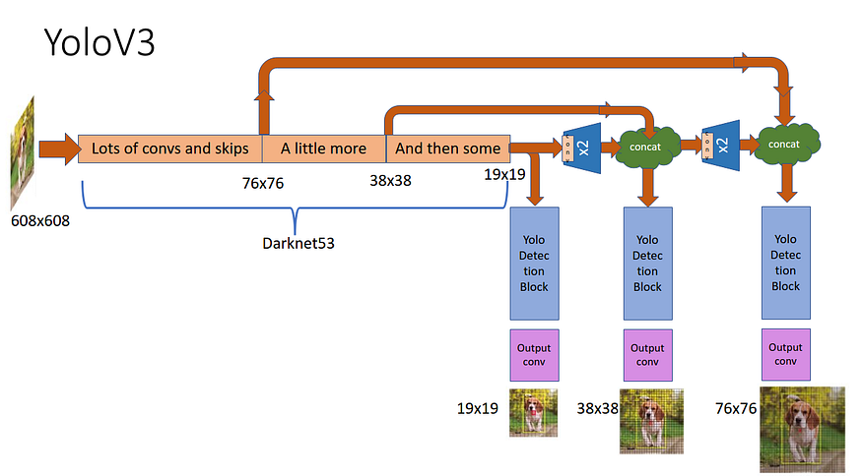

Code Editors used: Jupyter Notebooks, Arduino IDE



DESIGN SPECIFICATIONS

System Architecture

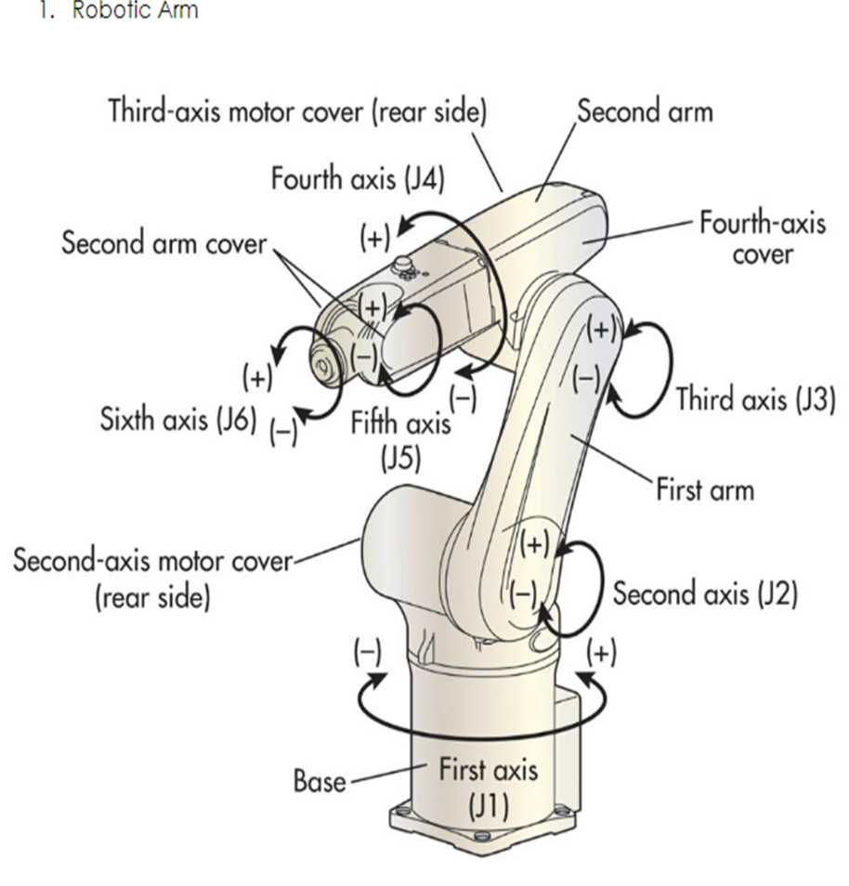

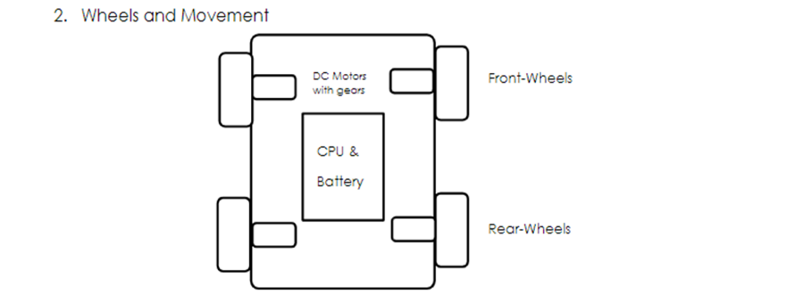

FIGURE 1: System Architecture for Robot

In this figure first robotic arm is displayed and then how chassis, wheels are joined together with servos and motors so that movement through wheel can happen and robotic arm can also move so that it can pick up the object which is detected by the esp32 cam which is attached on robotic arm

Design Level Diagrams
The following section addresses the design of the system from various aspects through different types of design level diagrams.

4.2.1 Sequence Diagram

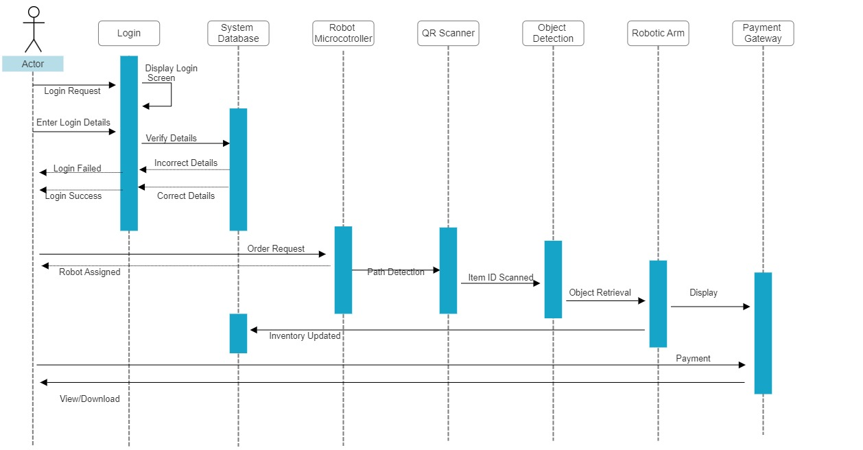

FIGURE 2: Sequence diagram for Robotics based Intellishop

The various sequence of activities and sub-processes involved is depicted in the sequence diagram in figure 2.

4.3 User Interface Diagram

4.3.1 Class Diagram

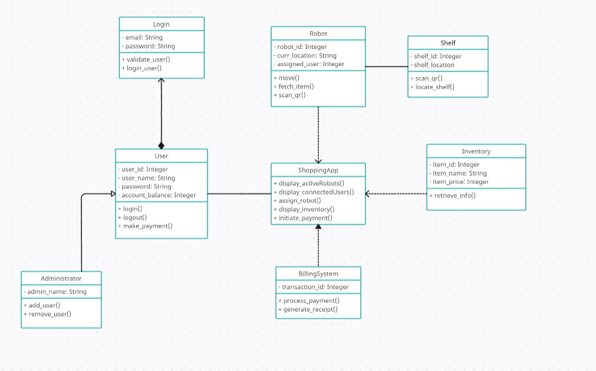

FIGURE 3: Class diagram for Robotics based Intellishop

The figure 3 above shows the different classes that represent the system and their relationships among each other.

4.3.2 Use case diagrams:

FIGURE 5: High level use-case diagram for Robot based Intellishop

FIGURE 5 depicts the high-level use-case diagram listing all the major use cases that system can be used for and the roles of the user and the robot.

TABLE 5: Use case template for Image Colorization use case

Use Case: | Order Item
Use Case ID: | 1
Primary Actor: | Customer
Goal in context: | To request item from the store using an application and get that item from robot
Preconditions: | The system has a login facility and the facility to order items using the app. The customer must be registered and logged in.
Trigger: | The customer decides to order something from the retail shop.
Scenario: | - The customer logs onto the app with their previously registered details.  - The customer enters their customer ID and password.  - The customer selects the ‘item’ which is available in the store.  - From database information regarding this travel to robot through nodeMCU.  - The robot processes the request and retrieves information about the item from the backend server, including its location in the store. Robot using arm then pick the object.  - The robot uses its camera array and navigation system to navigate to the item.  - The robot uses its arm and gripper to pick up the item and add it to the customer's cart.  - The robot confirms to the customer that the item has been added to the cart.
Alternative flow: | - If the item is not in stock or cannot be found, the robot informs the customer.  - If the robot encounters an obstacle or cannot reach the item, it informs the customer and offers assistance from a human store employee.
Exceptions: | The user ID or password is incorrect. Customer re-enters the correct ID and password.
Post conditions: | The item has been shipped to the cart and customer can order something else now.
Supporting actor(s): | Deep learning model, Robot

Activity Diagrams

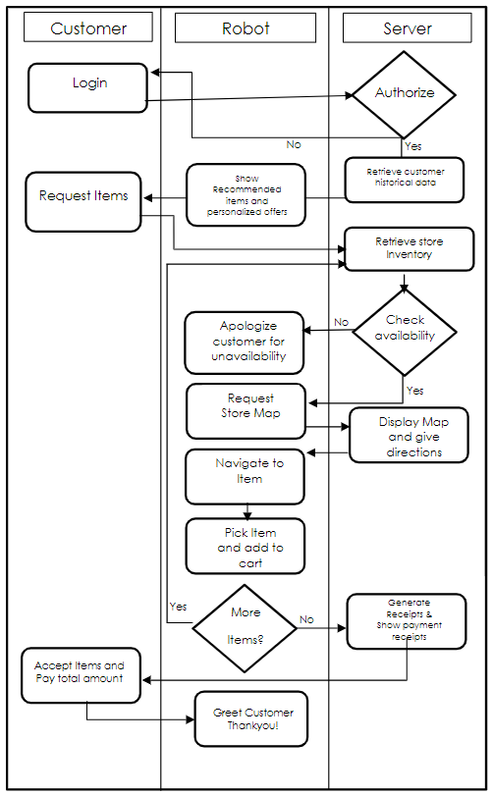

FIGURE 6: Swimlane activity diagram for Robotics based Intellishop

4.4 Snapshots of Working Prototype

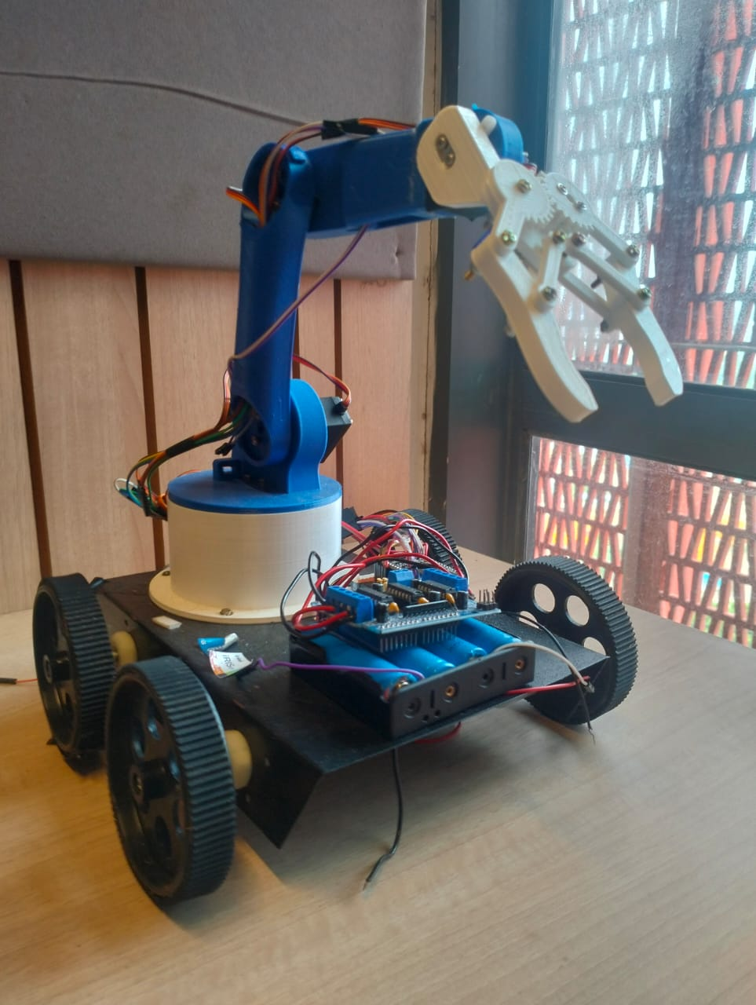

Figure 7: Working prototype (Robot)

Conclusions and Future Scope

  - Work Accomplished

Hardware Design and Assembly:
Designed and constructed a robot chassis with integrated wheels for mobility. Successfully integrated ultrasonic sensors for obstacle detection and navigation. Assembled the hardware components, including motors, sensors, and power supply.

Software Development:
Used an AI model training pipeline for object recognition using machine learning techniques.

Mobile Application Development:
Designed and developed a user-friendly mobile application for both Android platform.
Implemented features for user registration, item request submission, and request tracking.
Established secure communication protocols between the mobile app and robot software.

AI Model Training:
Collected and preprocessed a diverse dataset of product images for training.
Trained a machine learning model for object recognition.

Successfully integrated the hardware components, software algorithms, and testing with AI model. Verified the robot's navigation, obstacle avoidance, and object recognition capabilities.

Developed interaction behaviors, enabling the robot to identify customers, receive requests, and deliver items.

User Experience and Interface Refinement:
Iterated on the mobile app's user interface design based on user feedback.
Refined robot behaviors to ensure they were intuitive and user-friendly.

5.2 Conclusions

In conclusion, the AI-Enabled Robotic Retail Assistant project represents a successful amalgamation of cutting-edge technology and innovative design to enhance the retail experience. Through meticulous hardware assembly, software development, and AI model training, we have achieved the creation of a functional robotic system capable of autonomously navigating store environments, recognizing a diverse range of products, and engaging customers through a user-friendly mobile application. This project not only addresses the practical need for efficient and personalized customer assistance but also underscores the potential of technology-driven solutions to reshape traditional industries. By seamlessly integrating hardware, software, and AI, we have ushered in a new era of retail service, demonstrating how technological advancements can significantly elevate customer convenience, engagement, and satisfaction. As we reflect on the accomplishments achieved throughout this endeavor, it is clear that the AI-Enabled Robotic Retail Assistant project stands as a testament to the power of interdisciplinary collaboration, innovative thinking, and the continuous pursuit of excellence in modern engineering and automation.

5.3 Environmental, Economic and Social Benefits

The AI-Enabled Robotic Retail Assistant project offers a multitude of environmental, social, and economic benefits that extend beyond its technological achievements. From an environmental perspective, the integration of robotics and AI contributes to resource optimization by minimizing human-intensive tasks and streamlining operations. This reduction in labor-intensive processes potentially leads to decreased energy consumption, contributing to a more sustainable retail environment. Additionally, the project's focus on efficient navigation and path planning can minimize the robot's overall footprint within the store, optimizing space utilization.

On a social level, the robotic retail assistant enhances customer experiences by providing personalized and efficient service. By addressing customer needs promptly and accurately, the project fosters increased customer satisfaction and engagement. Moreover, the project promotes inclusivity by offering an accessible and intuitive interface through its mobile application, catering to a diverse range of users, including those who may require additional assistance.

Economically, the project introduces several avenues for improvement. Through automation, retailers can optimize labor allocation, potentially reducing operational costs associated with customer assistance. The efficient retrieval and delivery of items contribute to shorter wait times for customers, enhancing their shopping experience and potentially increasing sales. Moreover, by gathering and analyzing data on customer preferences and interactions, retailers can make informed decisions to tailor their offerings, leading to better-targeted marketing strategies and inventory management.

In conclusion, the AI-Enabled Robotic Retail Assistant project offers a holistic approach to technological advancement, addressing environmental concerns, enriching social interactions, and bolstering economic efficiency. Through its multifaceted benefits, the project exemplifies the potential of technology to not only innovate retail practices but also to contribute positively to broader societal and economic dimensions.

5.4 Future Work Plan

The AI-Enabled Robotic Retail Assistant project has paved the way for an exciting future with numerous possibilities for expansion, enhancement, and broader adoption. The success of the project lays the foundation for several future plans aimed at further improving customer experiences, embracing emerging technologies, and extending the project's impact.

1. Advanced AI and Machine Learning: Continuously refining the AI model for object recognition opens doors to more accurate and efficient product identification. Further exploration of deep learning techniques, such as convolutional neural networks (CNNs) and recurrent neural networks (RNNs), could enhance the robot's ability to recognize complex items and adapt to new products.
2. Enhanced Interaction and Personalization: Introducing natural language processing (NLP) capabilities enables customers to communicate with the robot through voice commands or text input. This elevated interaction level enhances customer engagement and furthers the project's goal of personalized assistance.
3. Storewide Integration and Inventory Management: Expanding the project to include integration with the store's inventory management system offers real-time updates on product availability. The robot could assist with inventory checks, restocking, and optimizing product placement for improved sales.
4. Multi-Store Implementation: Scaling the project to multiple retail locations or chain stores amplifies its impact and demonstrates its adaptability across different environments. Each deployment can be tailored to the specific layout and needs of each store.
5. Sustainability and Energy Efficiency: Exploring ways to make the robot more energy-efficient, such as implementing sleep modes when idle or utilizing renewable energy sources for charging, aligns with environmental concerns and showcases the project's commitment to sustainability.
6. Predictive Analytics: Leveraging the collected data to develop predictive analytics models can help retailers anticipate customer preferences, trends, and demand patterns. This informs strategic decision-making, stock replenishment, and marketing campaigns.
7. Customer Engagement Enhancements: Incorporating augmented reality (AR) or virtual reality (VR) features into the mobile app offers customers immersive experiences, allowing them to virtually explore products or receive guided tours of the store.
8. Collaborative Robots (Cobots): Investigating the integration of collaborative robots that work alongside human staff can further optimize processes like restocking shelves or assisting with more intricate customer queries.
9. Continuous Improvement through User Feedback: Regularly gathering user feedback and conducting surveys enables iterative improvements to the system's design, functionalities, and user interface.
10. Ethical and Social Considerations: Exploring ethical guidelines for AI in retail, ensuring customer data privacy, and addressing potential biases in the AI model's object recognition capabilities are crucial for responsible and equitable deployment.
11. Partnerships and Research Collaborations: Collaborating with academic institutions, technology partners, and retail organizations can provide new insights, research

REFERENCES

- Machine learning for internet of things data analysis: a survey Mohammad Saeid Mahdavinejad, Mohammadreza Rezvan, Mohammadamin Barekatain, Peyman Adibi Payam Barnaghi, Amit P. Sheth
https://www.sciencedirect.com/science/article/pii/S235286481730247X?via=ihub
- How Technology is Changing Retail: Venkatesh Shankar, Kirthi Kalyanam, Pankaj Setia, Alireza Golmohammadi, Seshadri Tirunillai, Tom Douglass, John Hennessey, J.S. Bull, Rand Waddoups
https://www.sciencedirect.com/science/article/abs/pii/S0022435920300695
- YOLOv3: An Incremental Improvement, by Joseph Redmon, Ali Farhadi
https://arxiv.org/abs/1804.02767v1
- Shopping intention at AI-powered automated retail stores (AIPARS) by Rajasshrie Pillai, Brijesh Sivathanu, Yogesh K. Dwivedi
https://www.sciencedirect.com/science/article/abs/pii/S0969698919302887
- “How artificial intelligence can change the core of marketing theory” by Roberto Grandinetti
https://pdfs.semanticscholar.org/aacc/cfb5a35fb9cdd8da825c4bd12ff3acc427f2.pdf
- Taking the fiction out of science fiction: (Self-aware) robots and what they mean for society, retailers and marketers by Hector Gonzalez-Jimenez
https://www.sciencedirect.com/science/article/pii/S0016328717300617
- Developing and validating a service robot integration willingness scale by Lu Lu, Ruiying Cai, Dogan Gursoy
https://www.sciencedirect.com/science/article/abs/pii/S0278431918306455
- Robots in Retail Marketing: A Timely Opportunity by Praveen Kumar Donepudi
https://i-proclaim.my/journals/index.php/gdeb/article/view/527
- The role of the human-robot interaction in consumers’ acceptance of humanoid retail service robots By Christina Soyoung Song, Youn-Kyung Kim
https://www.sciencedirect.com/science/article/pii/S014829632200323X

